**ASSIGNMENT 13.1**

PROBLEM STATEMENT:

**Create a Scala application to find the GCD of two numbers**.

Solutions:

(i) Scala Program to execute GCD of two numbers

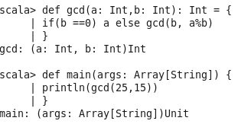

(ii) Output of the above program:

